# Project Brief: Sarah Abebe

# Summary

The Watch It Outside, based in Boston, aims to create an online presence for its coming event through a website. Watch It Outside host film shows in the open air and it is the world’s largest agency of its kind around the world. The Company would like to convey important information to its audience regarding the coming event and most importantly conduct a pre-registration to estimate the resources for a smoother flow on the 3 days of the event. The company would like to display the films on their website, along with other pertinent Museum information and content.

# Stakeholders

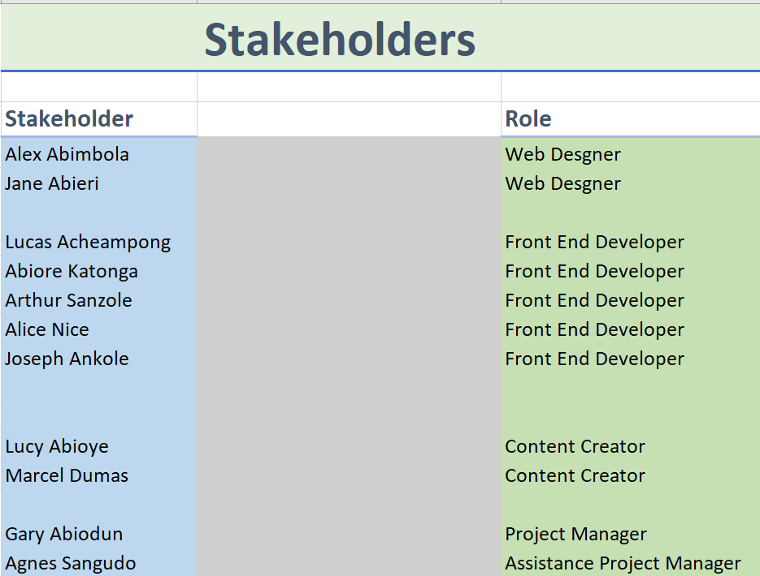

# Goals

Our team will develop a website prototype to create a more robust web presence for the company thus help them publicize their oncoming event make them more accessible to film funs in Boston City to do a pre-registration. In addition, Watch it Outside would like the site to achieve these goals:

1. Display large-format images of films in a beautiful, uncluttered way.
2. Encourage people to pre-register for the event.
3. Create opportunities for more editorial and blog content.
4. Make the site responsive so users can view all content on mobile devices.
5. Display important Company information, including event dates, location, links to the company’s social media platforms and other special websites, and the films to expect.

# Budget

# Timeline

|  |  |  |
| --- | --- | --- |
| Steps | Duration | Date |
| Develop the website design | 1 week | July 02, 2020 |
| Code the website wireframes | 1 week | July 09, 2020 |
| Develop content for the website | 1 week | July 02, 2020 |

# Technical specifications

Key Pages:

1. Watch it Outside Homepage
2. About Us Page
3. News Page
4. Registration Page

The Home Page is the first page the user is directed to when they visit the website for the first time. It has all the significant information the user could be interested in regarding the upcoming events. Additionally, it has links that will allow the user to navigate to other pages of the website and buttons that prompts the user to take action like registering for the event.

The About Us Page gives the user a brief history and the purpose of Watch it Outside Company.

The News Page contains two pages: Boston City News AND Boston Garden News.

The Registration Page allows the user to book for the upcoming events. It has a simple form that allows the user to input their details like name and email and a button submit.

Technologies Used:

1. HTML
2. CSS
3. Bootstrap
4. JavaScript

HTML, CSS, and JavaScript are the core components of any modern website. HTML is a markup language that dictates layout of the website. In other words, it lays down the basic structure also called the skeleton of the website.

CSS is a styling language. It helps format the web pages by giving them custom colors, font sizes, media orientation and altering the default flow given by the HTML to fit various views depending on the situation.

JavaScript is a programming language that adds a dynamic touch to the website. The language was used to run the countdown timer on the home page.

Bootstrap is CSS framework that focuses on webpage responsiveness. I used this technology to boost productivity and reduce the development time while making the website as responsive as possible meaning it can be accessed by a wide range of devices with varying screen sizes and orientation without any adverse page alterations.